Final Lab Report
Author: Seth Ricks
Lab Partner: Ian Fleming
Brother Watson: ECEN 340
12/10/2025
Purposes:
1. To define a complex digital system
2. To collaborate with others on your design
3. To implement a complex digital system
4. To give a technical report

Overview:
For this lab, you will be asked to research and design a complex digital system, such as a CPU or a four-function Calculator with real-time memory. You will work in small groups to define and complete this design. The group sizes should be 1 to 3 individuals (the more people, the more complex the project should be).

Peer Reviews:
Each project will have two reviews—one review will take place after the project definition, and the second review will take place after the project completion (or near completion). Class time will be available for these reviews.

The reviewing body will consist of all members of your design team and at least two others who are not part of your design team.

Each student will review the projects of at least two other projects and give feedback.

Scope of Project:
Each project must contain at least 3 elements from the technology inclusion list.

Technology Inclusion List: (Chosen Highlighted in Yellow)
Finite State Machine (at least 3 states)
Real – Time Memory access at 100MHz
Higher level Math Functions (Multiply or Divide)
Keyboard or Mouse I/O
7-segment display
External Sensors (light, sound, off-board switches)
VGA Port
Parallel Interface to Other Board
Serial Interface to Other Board
Analog to Digital Converters (ADCs) or Digital to Analog Converters (DACs)
Other approved technology: Joystick

Functionality Demonstration:
Each project must be demonstrated to the instructor. A video recording is sufficient to demonstrate the project. The video should be submitted along with a written report.

Written Report:
A report will be written describing the project and the results. This report should contain:
- First and second peer review notes. Include the names of those present and also document the comments that were made.
- A description of the project. Include diagrams of the project if it includes external components.
- Verilog code.
- Figures and graphs necessary to describe the project.
- A conclusion statement. As part of the conclusion statement, the level of functionality should be discussed.

Results/Report:
For our final project, we decided to combine the VGA port on our BASYS3 board with an external joystick. To accomplish this, we first needed to outline our project goals. We also split the project up into two parts and made goals for when we wanted our separate parts completed. Our responsibilities can be seen in Table 1 below.
Role | Name | Responsibilities
Team Leader | Seth Ricks | - Configure Joystick
Team Member | Ian Fleming | - Configure VGA Drivers
Table 1: Project Responsibilities

The following were our timeline goals:
Date: Monday December 1st
- Ian goal: finish configuring VGA driver
Date: Saturday December 6th
- Ian goal: Create simple moving drawing
- Seth goal: Finish Joystick
Date: Monday December 8th (during lab)
- Come together and combine portions
Date: Saturday December 13th
- Lab Finished, Reports done

We were able to meet these goals successfully, including the combining of our separate portions. We found that splitting our project up into two pieces resulted in a quicker realization of our goals. We designed our separate modules with the other in mind, meaning that we knew they were going to be combined.
The following figures (Figures 1-2) are our peer reviews. These were done before and after our project completion. A transcription of these figures is included below each respective image.
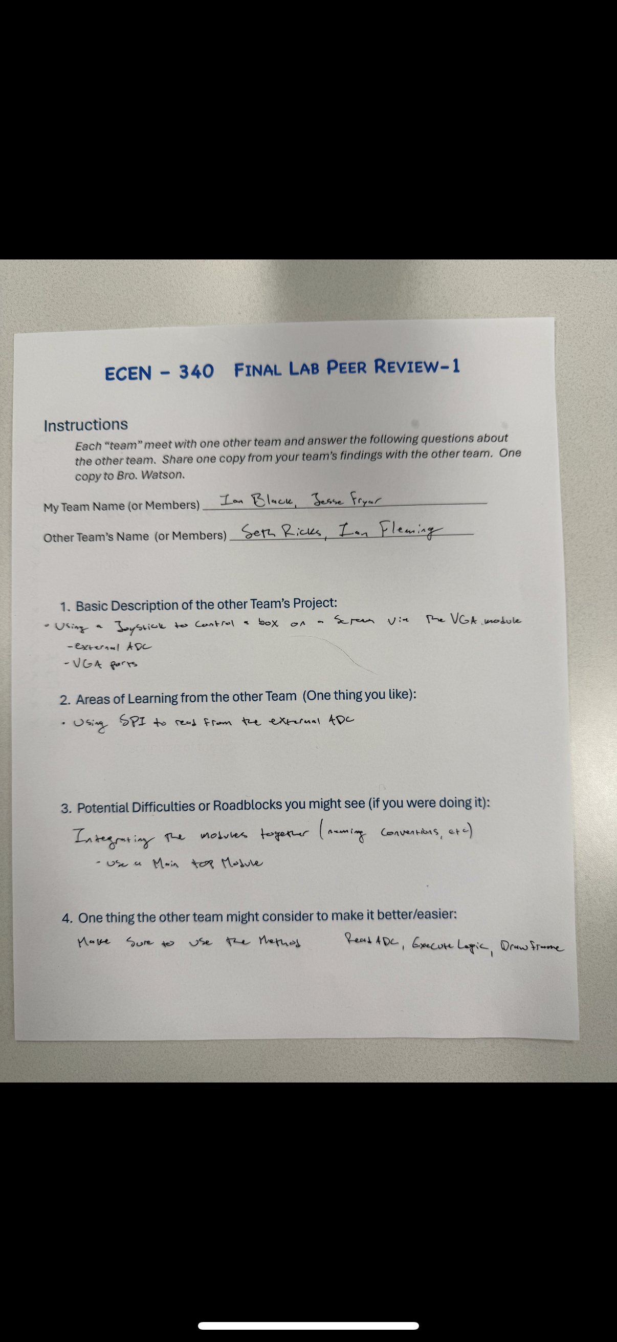
Figure 1: Final Lab Peer Review 1

Peer Review 1 Transcription:
ECEN – 340 Final Lab Peer Review-1
Instructions
Each “team” meet with one other team and answer the following questions about the other team. Share one copy from your team’s findings with the other team. One copy to Bro. Watson.
My Team Name (or Members): Ian Black, Jesse Fryer
Other Team’s Name (or Members): Seth Ricks, Ian Fleming
1. Basic Description of the other Team’s Project:
- Using a joystick to control a box on a screen via the VGA module
- External ADC
- VGA ports
2. Areas of Learning from the other Team (One thing you like):
- Using SPI to read from the external ADC
3. Potential Difficulties or Roadblocks you might see (if you were doing it):
Integrating the modules together (naming conventions, etc)
- Use a main top module
4. One thing the other team might consider to make it better/easier:
Make sure to use the method: Read ADC, execute logic, draw frame

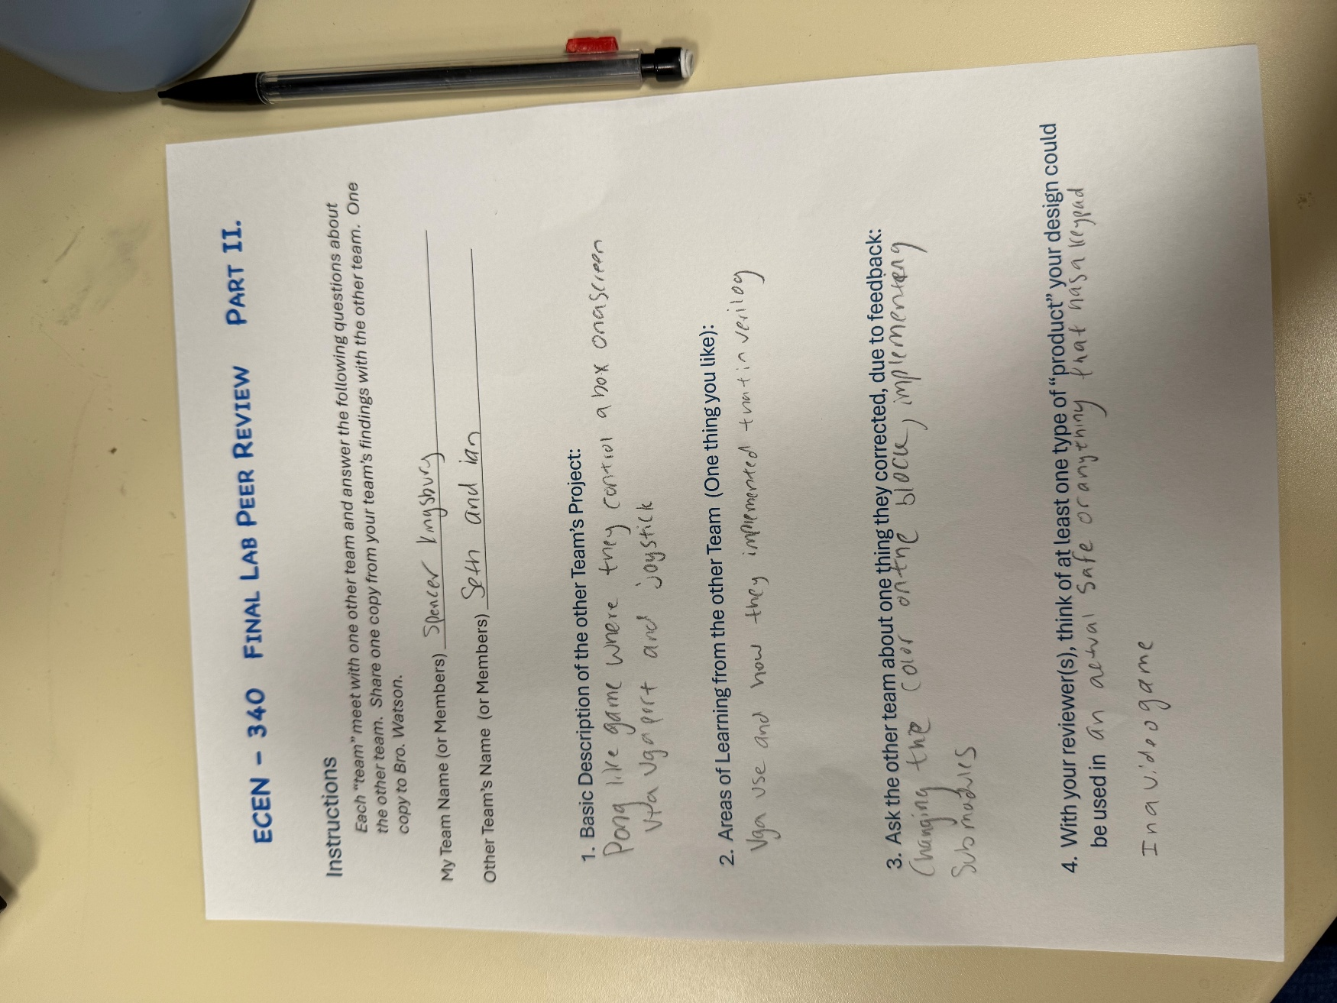
Figure 2: Final Lab Peer Review 2

Peer Review 2 Transcription:
ECEN – 340 Final Lab Peer Review-2
Instructions
Each “team” meet with one other team and answer the following questions about the other team. Share one copy from your team’s findings with the other team. One copy to Bro. Watson.
My Team Name (or Members): Spencer Kingsbury
Other Team’s Name (or Members): Seth Ricks, Ian Fleming
1. Basic Description of the other Team’s Project:
- Pong-like game where they control a box on a screen via VGA port and joystick
2. Areas of Learning from the other Team (One thing you like):
- VGA use and how they implemented that in Verilog
3. Ask the other team about one thing they corrected, due to feedback:
- Changing the color on the block, implementing submodules
- Use a main top module
4. With your reviewer(s), think of at least one type of "product" your design could be used in:
- In a video game

At a high level, our project incorporates a joystick, an analog-to-digital converter (ADC), an FPGA, and a monitor. We brainstormed this idea using Figure 3 below.
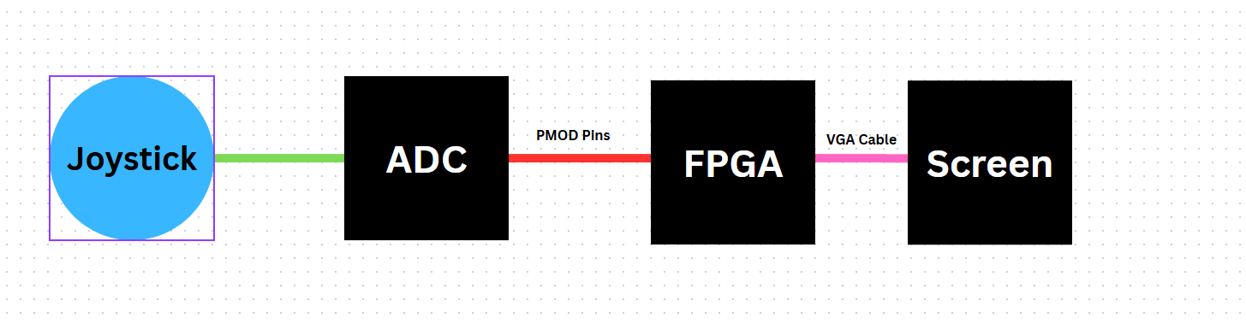
Figure 3: High-Level Diagram of Project

As mentioned above, we were required to include 3 of a list of elements. The elements that we chose to include were: Finite State Machine (3 states), VGA Port, Analog to Digital Converter, and a Joystick. I will describe the project with each of these elements in mind.
First, I will describe the joystick Verilog code, particularly because it was the portion of the lab that I was tasked with completing. To use the joystick, I needed to use an ADC. This was to take the analog signals from the joystick and convert them into a digital signal that the board could use. An image of my chosen ADC can be seen in Figure 4 below.
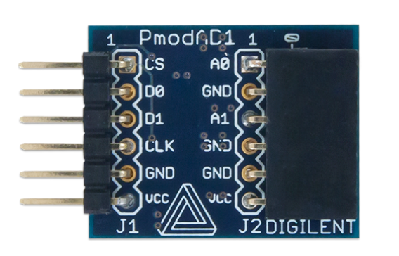
Figure 4: Pmod ADC
The first thing I tried to do was simply get an SPI communication protocol with the ADC up and running. This proved to be much more difficult than expected, as this board did not use standard SPI communication protocol. I was trying to use MOSI and MISO protocol, assigned to D0 and D1 respectively. It wasn’t till I researched this board that I found this statement:
“The Pmod AD1 communicates with the host board via an SPI-like communication protocol. The difference between the standard SPI protocol and this protocol is manifested in the pin arrangement on this Pmod. A typical SPI interface would expect a Chip Select, a Master-Out-Slave-In, a Master-in-Slave-Out, and a Serial Clock signal. However, with the two ADCs on this chip both of the data lines, MOSI and MISO, are designed to operate only as outputs, making them both Master-In-Slave-Out data lines” (diligent.com).
This discovery led to the realization that my ADC didn’t use MOSI protocol, and was a read-only module. Once I understood this, and mourned the loss of my MOSI protocol code, I was able to successfully read from this board. I connected the joystick VRY, VRX, VCC, and GND pins to A0, A1, VCC, and GND pins of the ADC, respectively. I then connected the CS, D0, D1, CLK, GND, and VCC pins directly to the JB pins on the BASYS3 FPGA board. With the following code, seen in Figures 5-6, I was able to successfully read useful information from the joystick.

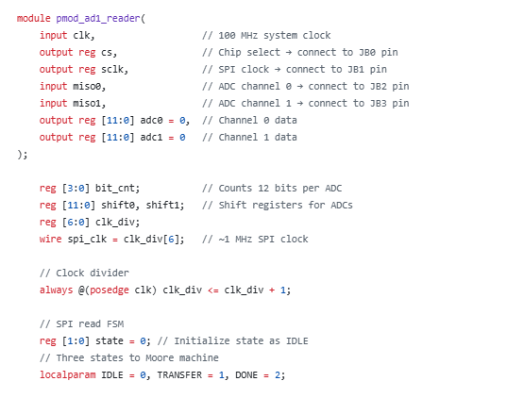
Figure 5: ADC Reader Definition

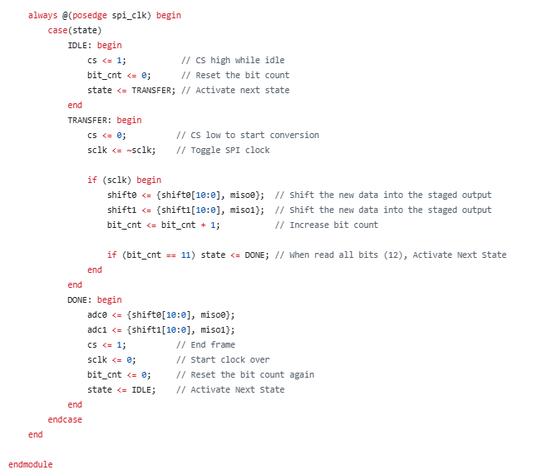
Figure 6: MISO Protocol State Machine

The state machine for this communication protocol is of particular interest in this report, as it is the backbone of working with the joystick. The basic idea is that the FPGA receives data from the ADC in packets of 12 bits. It started with the IDLE state, which initiates the sequence. It moves on the TRANSFER state, where the data is read. The data from both D0 and D1 are shifted into variables called shift0 and shift1, and the variable bit_cnt is incremented by one. Once the bit count reaches 12, it is time to move onto the DONE state. This is the state that assigns the read data to the outputs adc0 and adc1. This is what the top module, which will be discussed shortly, uses to determine the direction of the joystick. The state machine then starts over with the IDLE state.

The second portion of our project, the configuration and usage of the VGA port, is the part that I am less familiar with. This is because my partner wrote this code, as that was his assignment. Despite this, I will attempt to describe it.
The following images (Figures 7-8) are a portion of the Verilog code in a module called square. This is one of the modules that my partner wrote, which uses the VGA port to draw and control a simple square.

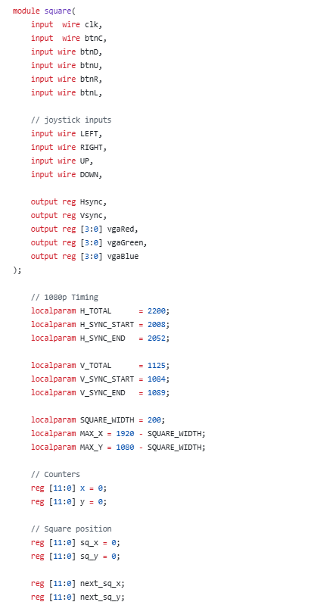
Figure 7: Square Module Declaration Figure 8: Square Module Variables

I will show the rest of this module in a moment, after discussing the top module. The top module is what my partner and I used to combine our portions of the lab. Because the top module in Vivado can only have port declarations that are on the physical board, the rest of our variables had to be declared as wires. This can be seen in Figures 9-10 below.

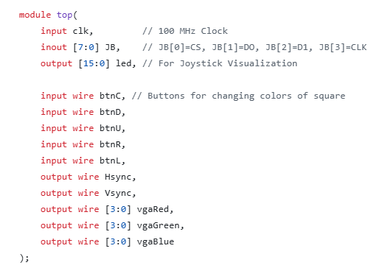
Figure 9: Top Module Declaration

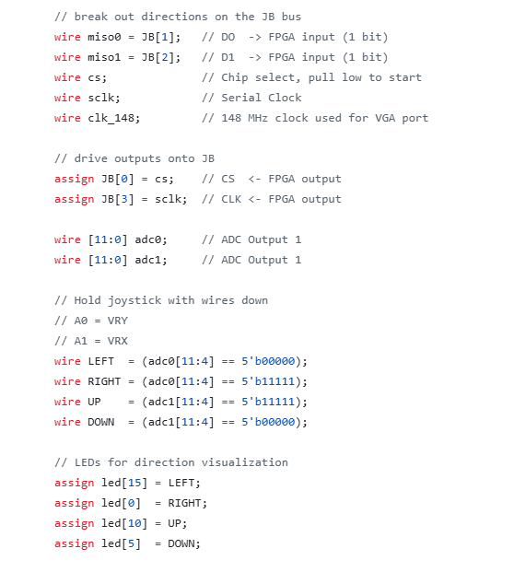
Figure 10: Top Module Wires

Inside of the top module we had to instantiate both our square and separate square and ADC modules. The Verilog code for this can be seen in Figure 11 below.
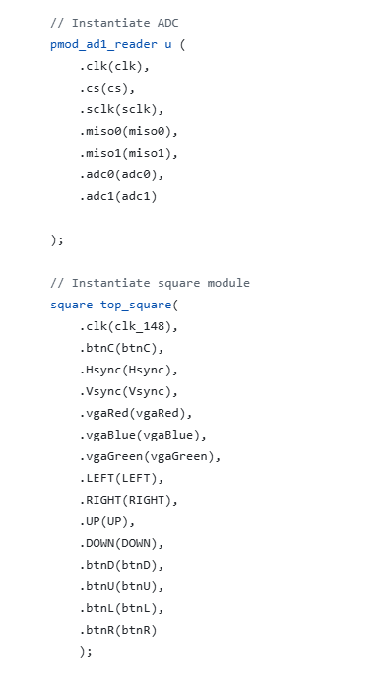
Figure 11: Square and ADC Module Instantiations

Notice that the variables LEFT, RIGHT, UP, and DOWN that were generated from the ADC logic are passed into the square module. These flags are used in the code in Figure 12, where the square on the VGA port moves according to these flags.

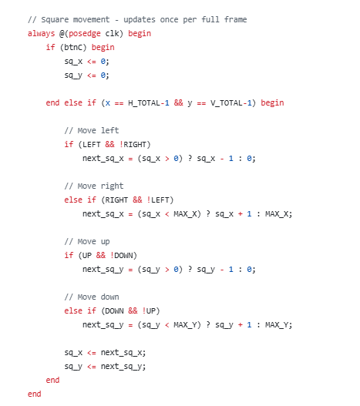
Figure 12: Direction Flags in Square Module

Finally, for a little bonus, my partner also created an always block in the square module that can change the color of the square. This is done with the btnD, btnU, btnR, and btnL buttons, the logic for which can be seen in Figure 13 below.
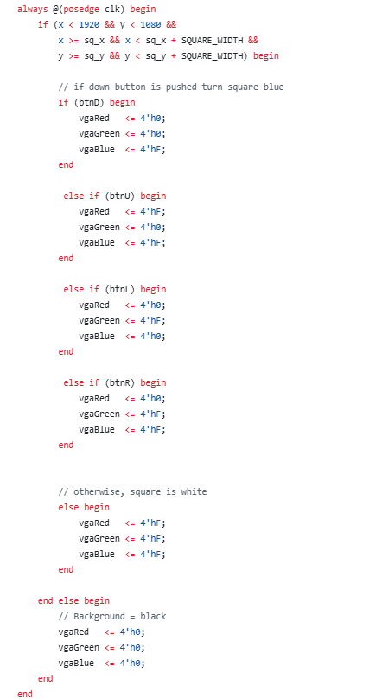
Figure 13: Square Color Changing Logic

After combining our portions of the lab, and after a little bit of syntax debugging, our lab worked as intended! The generated schematic can be seen in Figure 14 below.
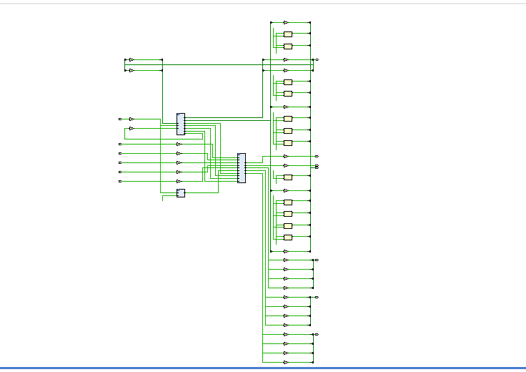
Figure 14: VGA with Joystick Schematic

Our project is fully functional as we designed it. The joystick moves the square around the screen, and the buttons on the FPGA change the colors of the square. It might not look like much, but we are proud of what we have done! Considering that this is all implemented in hardware, I would say that this is impressive. A video of our project working can be seen in Video 1 below. Note: after this video was taken, we decided to change the moving portion of the logic to be + or – 5 pixels, instead of 1. This made the movement of the square much more interesting than one pixel at a time, though we don’t have a video for it. The idea though is essentially the same.

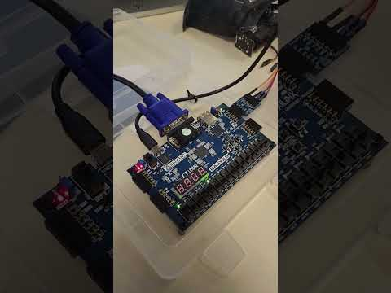
Video 1: Demonstration of Working VGA/ Joystick Project

Conclusion:
The functionality of the project is good and works as intended, meaning that we can control a displayed an object through a VGA port with a joystick. My lab partner and I were able to accomplish this with a combination of portioning out the project between the two of us, with the knowledge that we were going to combine them afterwards. It is due to our diligent planning and frequent updates that we were able to combine our modules so smoothly.

